# Computer Programming

## Practical file



### [Qr code Description automatically generated](https://github.com/Virat-Gupta/Computer-Programming-Practical-file)Made By:

Virat Gupta

CSDS-1

2022UCD2170

## PROGRAM 1

### Question:

Write a C program to input 3 numbers and print their average.

### Code :

### Output:



## PROGRAM 2

### Question:

Write a C program to input 3 numbers and print their average. 2. Write a C program to enter the radius of circle/sphere and compute its

1. Perimeter
2. Area
3. Volume

### Code:

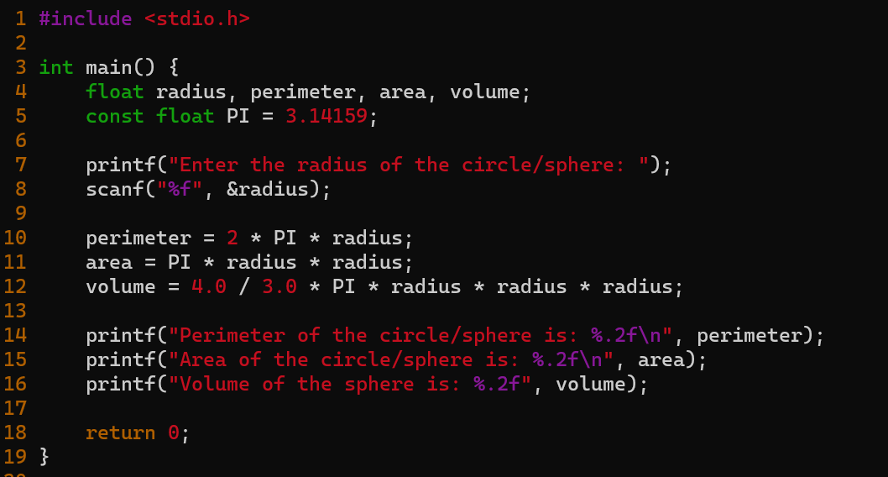

### Output:

## PROGRAM 3

### Question:

Write a program in C to show that Right shift effectively divides a number by 2 and a left shift effectively multiplies a number by 2.

### Output:

## PROGRAM 4

### Question:

Write a C program to find the roots of an quadratic equation

### Code:

### Output:

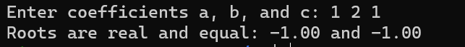

## PROGRAM 5

### Question:

Write down a function in C to implement bitwise AND, OR, XOR and NOT operations

### Code:

### Output:

## PROGRAM 6

### Question:

Given a n integer number write a program that displays the number as

Follows :

First line : All digits

Second Line :All except first digit

Third line : All except first two digits

..

Last line : The last digit.

### Code:

### Output:

## PROGRAM 7

### Question:

Write a program to enter an integer and print the sum of the digits in the

Integer.

### Code:

### Output:

## PROGRAM 8

### Question:

Write a C program to input an investment amount and compute its fixed

deposit cumulative return after 10 years at the rate of interest of 7.75%.

### Code:

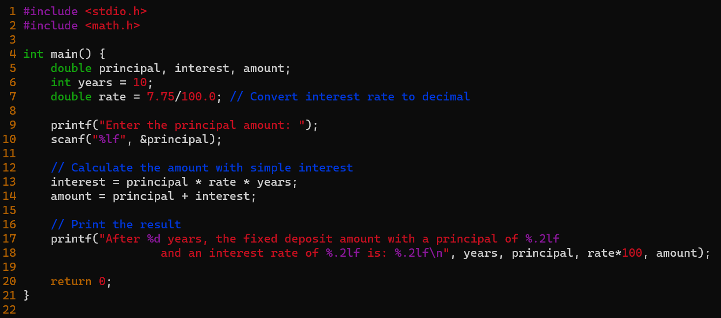

### Output:



## Program 9

*Refer program 4.*

## PROGRAM 10

### Question:

A company has categorized its employees at 4 different levels(from 1 to 4). For different employees at different levels the perks are as follows

|  |  |  |
| --- | --- | --- |
| LEVEL | TA | ENTERTAINMENT ALLOWANCE |
| 1 | 7000 | 3000 |
| 2 | 6000 | 2000 |
| 3 | 5000 | 1500 |
| 4 | 5000 | 1500 |

For Level 1 Basic salary is between Rs 40000 to 60000 and Tax rate is 10%

For level 2 Basic Salary is between Rs 30000 to 40000 and Tax rate is 8%

For level 3 Basic salary is between Rs 20000 to 30000 and Tax rate is 5%

For Level 4 Basic Salary is between Rs 15000 to 20000 and tax rate is 0

Gross Salary is sum of Basic salary, Perks and HRA which is 25% of Basic Salary

Tax is computed on Gross Salary. Net Salary is Gross salary- Income tax

Write a Program that will read Employees name, Level and Basic pay and will print Gross salary, Tax and Net Salary. Use Switch-case statement and if statements

### 

### Output:

## PROGRAM 11

### Question:

Given a number, write a program using while loop to reverse the digits of the number. For example number 12345 should be written as 54321.

### Code:

### Output:



## PROGRAM 12

### Question:

The numbers in the sequence 1 1 2 3 5 8 13 21..... are called Fibonacci numbers. Write a program using do...while loop to calculate and print the first m Fibonacci numbers.

### Code:

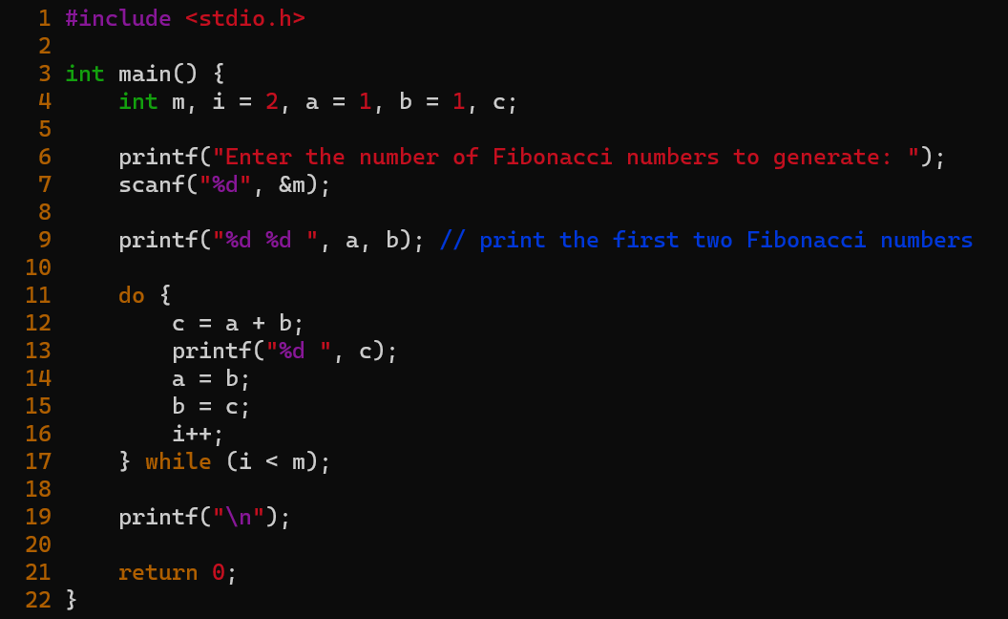

### Output:



## PROGRAM 13

### Question:

Write a program to evaluate the following functions to 0.0001% accuracy

### Code:

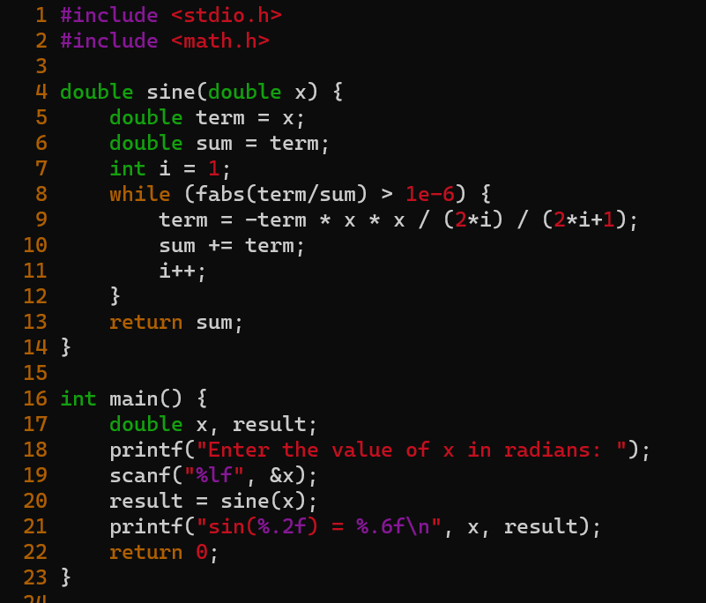

### Output:

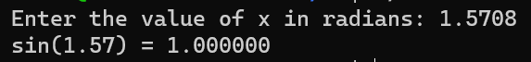

## PROGRAM 14

### Question:

Write a C program to display following Pattern:

1

1 2 1

1 2 3 2 1

1 2 1

1

### Code:

### Output:

## PROGRAM 15

### Question:

Given the two one dimensional arrays A and B which are sorted in ascending order. Write a C program to merge them into single sorted array C that contains every item from arrays A and B in ascending order.

### Code:

### Output:



## PROGRAM 16

### Question:

Write a program that will count the number of occurrences of a specified character in a given line of Text.

### Code:

### Output:

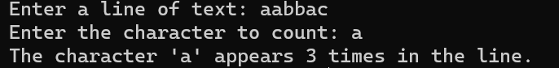

## PROGRAM 17

### Question:

Write a program to enter two 3 x 3 matrices and find their

1. sum
2. Multiplication
3. Transpose

### Code:

### Output:

## PROGRAM 18

### Question:

Write a program that counts the number of vowels, consonants and digits in a given line of string.

### Code:

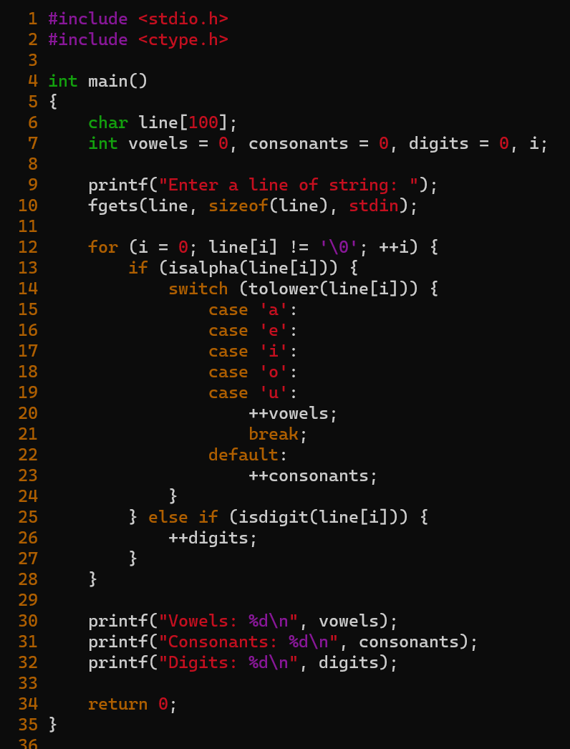

### Output:

## PROGRAM 19

### Question:

Write a program that replaces a substring with another string in a given line of text.

### Code:

### Output:



## PROGRAM 20

### Question:

Write a program using pointers to read an array of integers and print its elements in reverse order.

### Code:

### Output:

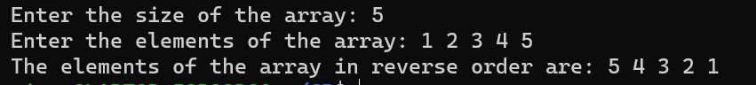

## PROGRAM 21

### Question:

Write a function (using pointer parameters) that compares two integer arrays to see whether they are identical. The function returns 1 if they are identical else 0.

### Code:

### Output:



## PROGRAM 22

### Question:

Write a program in C using pointers to implement insertion and deletion in a queue. A queue is a data structure that follows a first in first out i.e. the element to go in first is the one to come out first.

### Code:

### Output:

